Using [Pay.gov](https://www.pay.gov/public/home) for PUF payments

1. Type “Statistics of Income” into the search bar on the top right

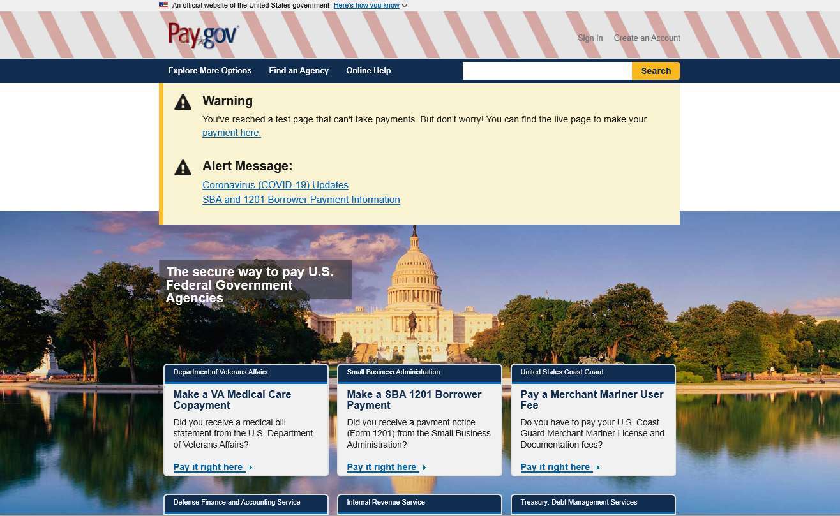

1. Click Continue

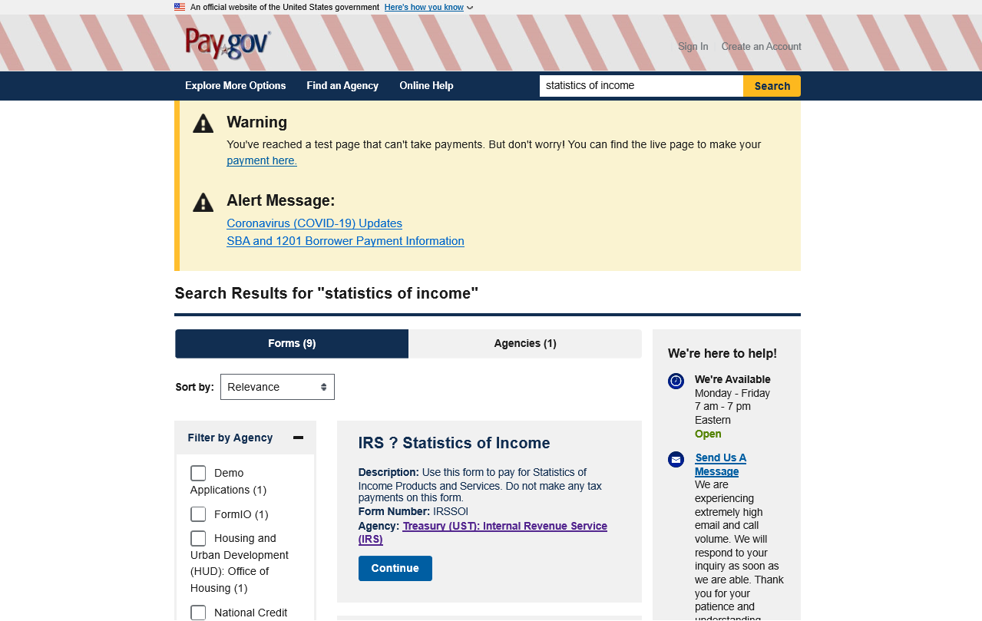

1. Click Continue to the Form

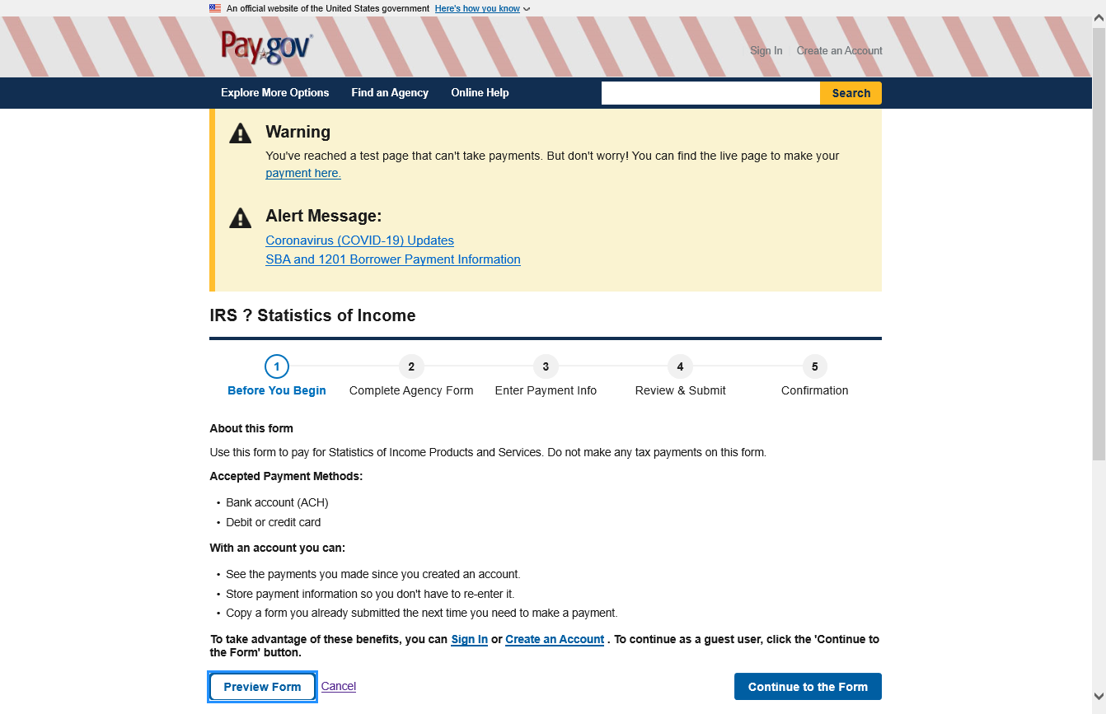

1. Type the name of your organization, SOI invoice number (from the invoice copy) and amount, and then click Submit Data

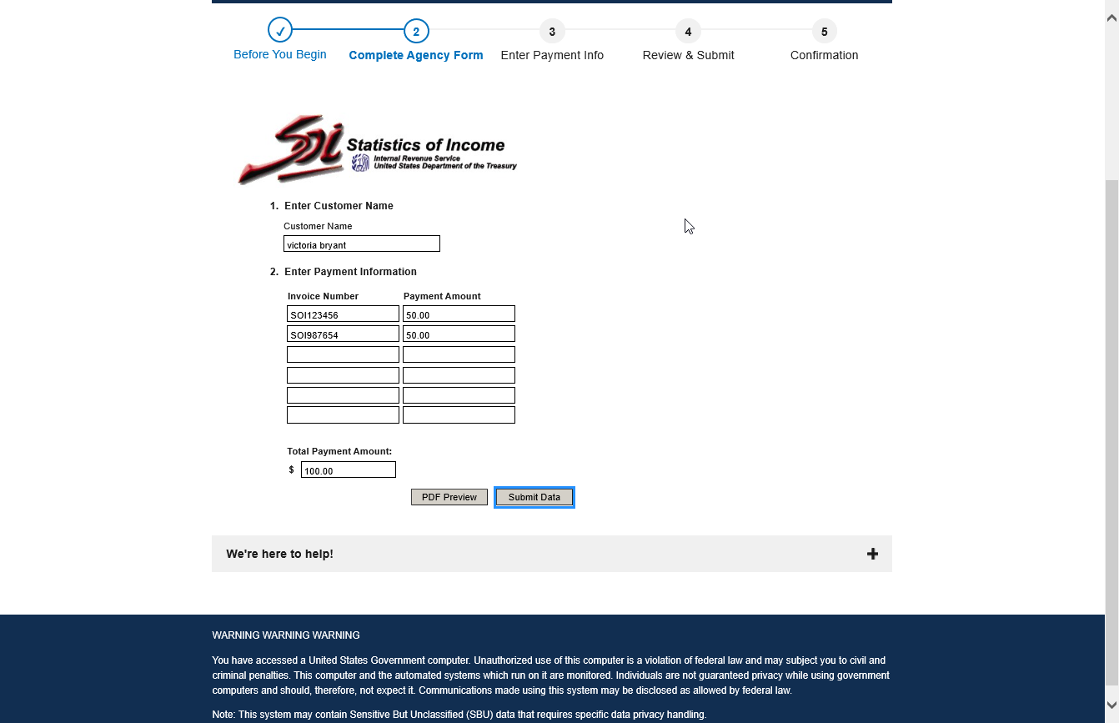

1. Confirm payment amount, select payment method, and select Next

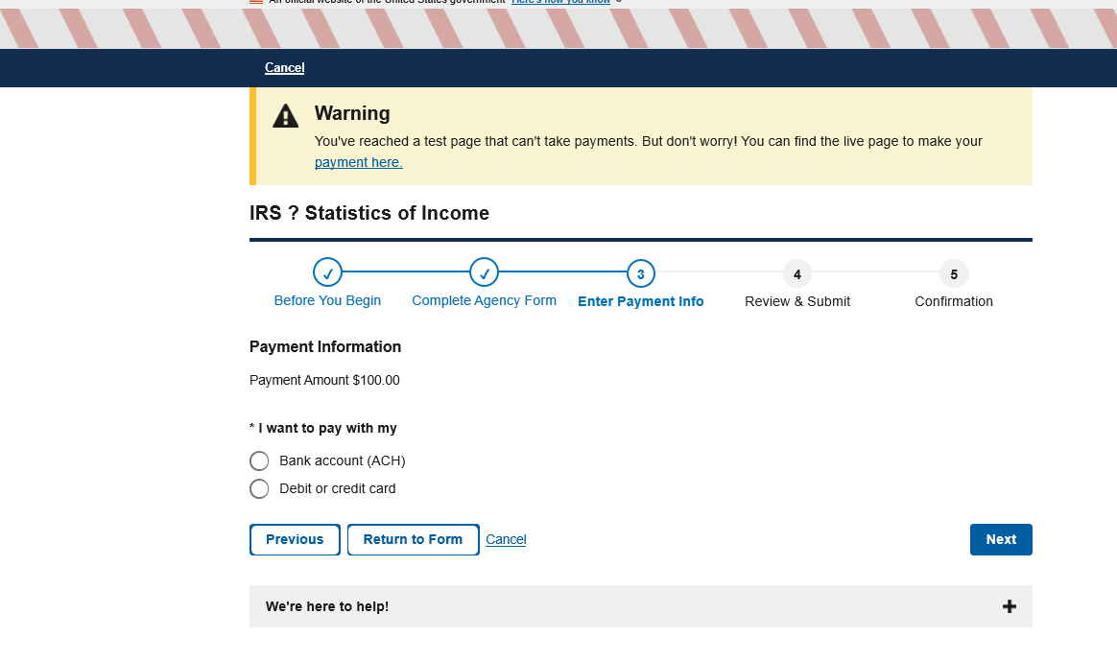

1. Please enter your email address in the first two boxes. Under CC, list the email addresses of [Evan.D.Avila@irs.gov](mailto:Evan.D.Avila@irs.gov) and [Victoria.L.Bryant@irs.gov](mailto:Victoria.L.Bryant@irs.gov) as shown below.

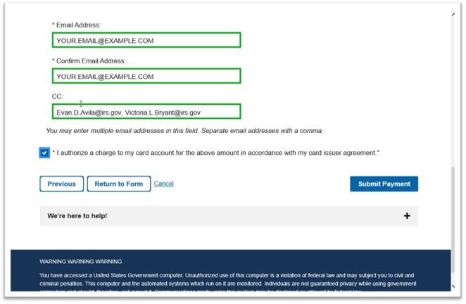

1. Click the box that authorizes the charge to the card and click Submit Payment when you are ready.

Thank you!